You are being asked to assist a Bank with its user profile section, as part of its Credit Journey Digitization initiative. The Bank is using React with Typescript for its web frontend.

The Bank asked you to develop the system that covers the User stories below, in a RESTful manner. During the Sprint Planning Session that you attended; it was estimated that the effort required shouldn't cost more than 2 Developer Story Points. Experience has shown that 2 Developer Story Points have been accomplished in a quarter of a day of a Developer's daily productive time, but this is obviously not always the case.

Task 1: Create a side bar with user profile section for sidebar (image for reference only).

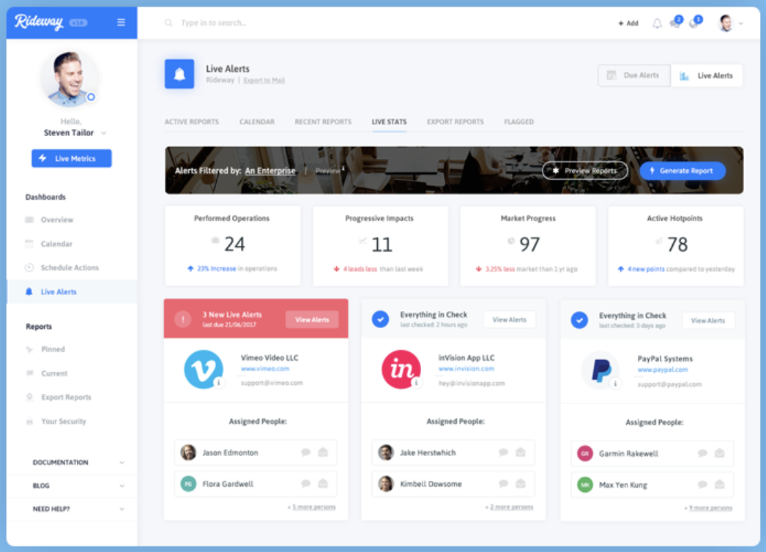

A. As a User, I want to be able to see my profile on the sidebar of the dashboard when I login.

B. As a User, I always want to see the sidebar visible through different pages of the dashboard.

Task Requirements:

1. Create a simple 2-column layout that has a fixed sidebar (with user details and 2 links e.g. Dashboard and Reports) and a content section.
2. Implement 2 routes (Dashboard and Reports) to change the content in the content section.
3. Make a REST API call to <https://jsonplaceholder.typicode.com/users/1> to fetch the user details.
4. The fetched user details must be persisted to Local Storage
5. Implement a simple unit test on sidebar to make sure that user detail is fetched.
6. (Bonus Point) Use <https://ant.design/> components for layout and sidebar etc.

Non-functional requirements:

- Make sure to use a .env file to for Base API URLs.

- The system shall be implemented in React with Typescript, using Yarn.

- The final deliverable shall be shared with the Tech Lead through a Git repository with a readme file with instructions.

- Make sure to be able to configure the start script to start against the specified BASE API URLs

- The deliverable shall have at least 60% of Unit & Integration testing coverage